Chapter 3: STP

Redundancy at OSI layer 1 & 2
Switch networks commonly have a redundant path that are linked between the same devices.
Redundant paths eliminate single point failure helping reliability.
STP – Spanning Tree Protocol
STP is a layer 2 protocol that helps with redundant links
Layer 2 loop issues
- Mac database instability
- Broadcast storms
- Multiple frame transmission

Issues with layer 1 redundancy
MAC database instability
1.Ethernet frames do not have time to live ( TTL) this means ethernet has no way to drop frames.
A host pc can be caught in a network infinite loop
Due to the constant changes to the MAC Address switches S3 & S1 do not know what to do with the information
Result in MAC database instability
- PC1 sends broadcast to frame S2
- S2 updates the mac address table
- S2 Forwards the frames out of all the ports expect the port that is needed to be sent
- S1 & S3 send the information to all the ports except the port that originally sent the request.
- S1 sends the frames to port 2 (Trunk3) while S3 updates the mac address

Broadcast storms
Broadcast storm- Is caused if there is to many frames sent out to layer 2 that it makes the network unreachable for legitimate network traffic
- Can cause denial of service
- Can develop within seconds and bring the network down

Duplicate unicast frames
- An unknown unicast frame is when the switch doesn’t have the correct MAC & the MAC it self doesn’t send out a frame
- Unknown unicast frames keep sending out loops to find the issue and get stuck in a loop issue

STP tree algorithm
- STP creates one logical path through the switch network
- Helps block redundant paths that could cause a loop
- STP helps bridge protocol data units between layer 2 devices
- A port on S2 can block a certain path so it allows the frames (Traffic) to only move from 1 specific path
- When Trunk 1 fails the blocked ports become unblocked to help traffic move on.

Port Roles
- Root bridge – One layer 2 device in a switch port
- Root port – one port on a switch that has the lowest cost to reach the root bridge
- Designated port – selected on per segment
- Alternate port – backup port for the designated port only
- Backup port – back up for root ports only

Root Bridge
- Lowest bridge ID
- Orignal BID has two fields
- Bridge priority
- MAC address
- Bridge priority is 32,768 (Can be changed)
- Has the lowest MAC address (Only if bridge priority is not altered)

Root path cost
- The cost helps determine the role of the port & whether traffic is blocked
- Can be modified with the command;
- Spanning-tree cost

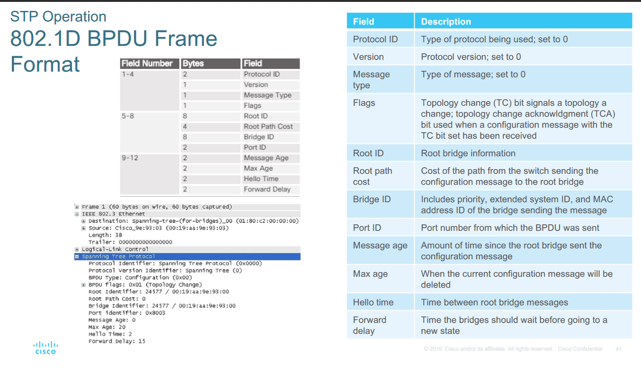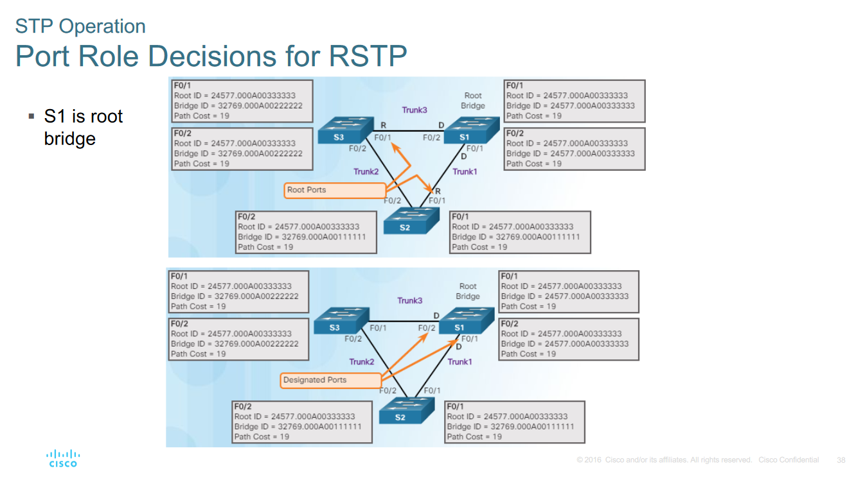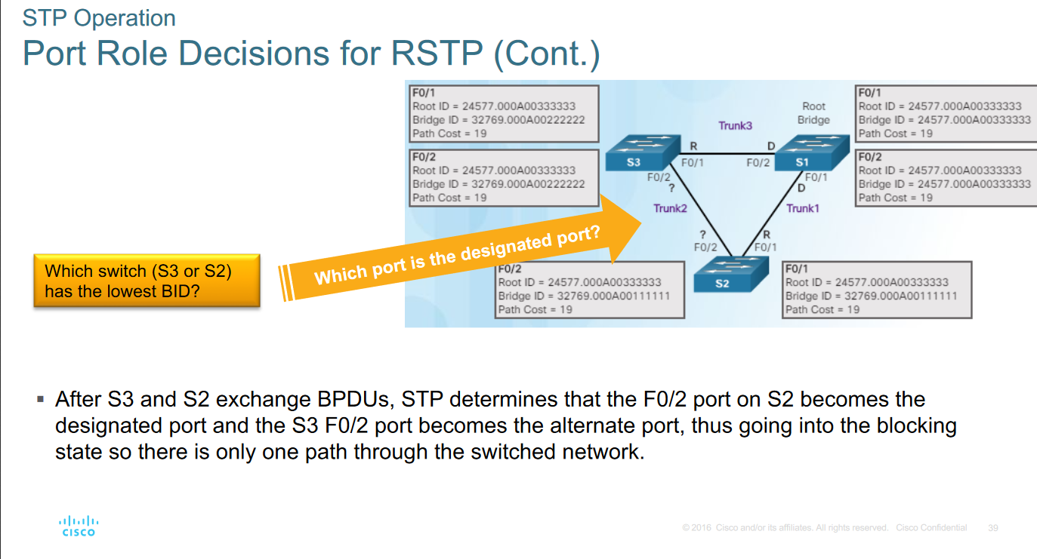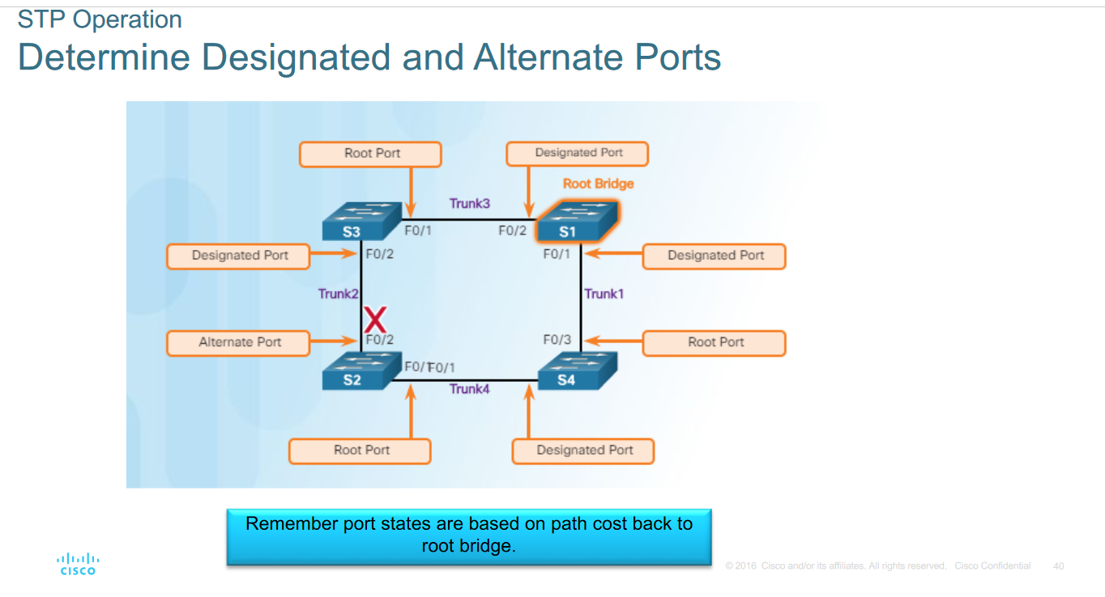

802.1d propagation and process
1. When a switch is powered on it gets assigned as root bridge unless stated otherwise
2. S3 compares root ID’s with S2
3.S1 Receives the information that S3 and S3 have acquired and sees if it the root bridge of the network.
4. S3 would send out information on who has been chosen as the root Bridge for e.g. S2

BID - Bridge ID
Extended System ID
- If the priority is all set to default, the lowest MAC determines the factor of BID
- The priority value can be modified to influence root bridge

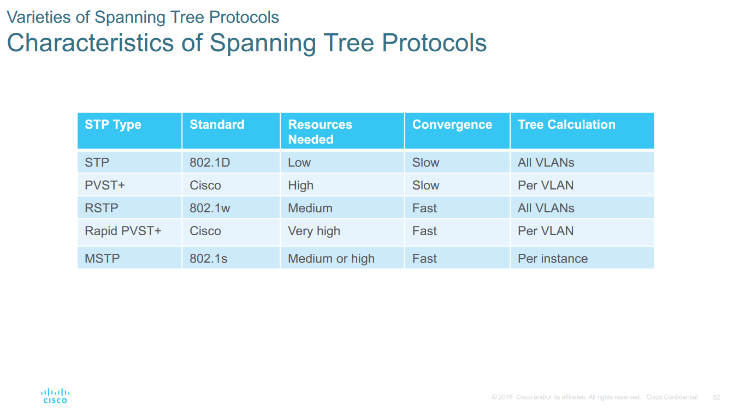

Overview of PVST+
- 802.1d defines a common Spanning Tree
- One spanning tree can be used for infinite switched networks (no matter the vlan)
- No load sharing
- One uplink must block all vlans
- Low CPU utilization

- Cisco PSVT+ - each vlan has its own spanning Tree
- One port can be blocking for one VLAN and forwarding for another vlan
- Can load balance
- Can stress CPU if large number of VLANs are used

Extended System ID and PVST+ operation
(PowerPoint page 32) Continue…..

